Q. (1-5): Study the given table carefully to answer the following questions.
Field Name | Shape | Side (in m) | Base (in m) | Height (in m) | Radius (in m) | Cost of flooring (in Rs. per sq. metre) | Cost of fencing (in Rs. per m)
A | Triangle |  | 16 | 12 |  | 50 | 20
B | Rectangle | 10 × 20 |  |  |  | 30 | 15
C | Square | 15 |  |  |  | 40 | 18
D | Parallelogram |  | 20 | 12 |  | 60 | 25
E | Circle |  |  |  | 10 | 45 | 22
Q1. What is the cost of flooring of A?
a) Rs.4000
b) Rs.4600
c) Rs.4800
d) Rs.5000
e) Rs.4400
Q2.What is the difference between the cost of fencing of C and that of B?
a) Rs.180
b) Rs.120
c) Rs.240
d) Rs.360
e) Rs.480
Q3. What is the ratio of the cost of flooring to that of fencing of field D?
a) 4 : 1
b) 6 : 1
c) 8 : 1
d) 9 : 1
e) 5 : 1
Q4. The cost of fencing of field E is approximately what percent of the cost of flooring of field C?
a) 10.5%
b) 19.46%
c) 18.71%
d) 15.36%
e) 13.82%
Q5. The cost of fencing of field C is what percent of the cost of fencing of field D?
a) 87.54%
b) 67.5%
c) 72.13%
d) 54.36%
e) 46.5%

Directions (1-5): Study the following the pie-chart and table carefully to answer the questions given below:
The following pie-chart shows the distribution of the monthly family budget of a person.
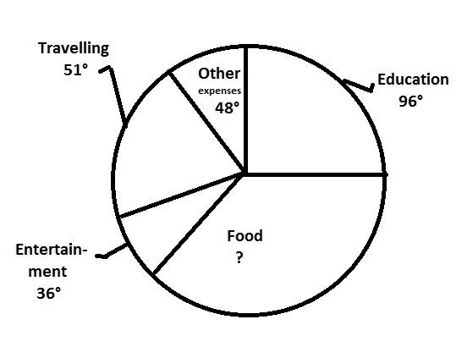
The following table shows the further distribution (in percent) of the above-mentioned items among the five family members i.e P (the person himself), W (his wife), Rahul (son), Rohit (son), and Preeti (his daughter). His monthly family budget is Rs. 1,20,000

 | Education | Food | Entertainment | Travelling | Other expenses
P | 10 | 30 | 10 | 40 | 20
W | 15 | 25 | 30 | 10 | 25
Rahul | 40 | 20 | 20 | 25 | 20
Rohit | 25 | 15 | 25 | 10 | 10
Preeti | 10 | 10 | 15 | 15 | 25
1. What is the average expenses of P?
1. Rs. 5620
2. Other than the given options
3. Rs. 5640
4. Rs. 5460
5. Rs. 5480

2. What is the approximate percentage increase in the amount Which Rahul enjoys for entertainment as compared to Preeti for the same?
1. 33%
2. 31%
3. Other than the given options
4. 37%
5. 35%
3. The average expenses of Rohit is approximately what percent of the average expenses of W (Wife)?
1. 76.4%
2. 81.5%
3. 79.5%
4. 83.5%
5. Other than the given options

4. Find the difference (in percentage of the budget) between the average expenses of Education and the average expenses on Entertainment of the couple?
1. 1.3%
2. 0.9%
3. 2%
4. Other than the given options
5. 2.5%

5. The total amount spent by Rahul on Travelling and Food is approximately what percent of the total amount spent by Preeti on Education and Food?
1. Other than the given options
2. 168%
3. 171%
4. 175%
5. 174%

