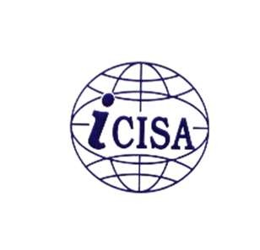
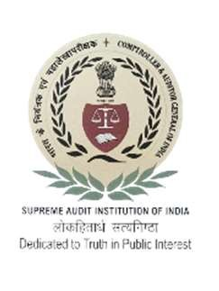
International Centre for Information Systems & Audit (iCISA)
Course Schedule
NTP on “Role of Audit”
(For Gr. A Officers of Military Engineering Services)
(15th to 17th April, 2025)
Date | Topic | Time (in hrs)
 | 15.04.2025 (Day-1)
 | Registration from 9:45 am
Session 1 15.04.2025  Tuesday | Introduction of participants | 10:00 – 10:15
Session 1 15.04.2025  Tuesday | Overview of the course | 10:00 – 10:15
Session 1 15.04.2025  Tuesday | Ethics & Accountability in Public Governance | 10:15 – 11:15
 | Mr. Krishna Mohan, Former Addl. Chief Secretary, Haryana
 | Tea Break | 11:15 – 11:45
Session 2 15.04.2025  Tuesday | Ethics & Accountability in Public Governance | 11:45 – 13:00
 | Mr. Krishna Mohan, Former Addl. Chief Secretary, Haryana
 | Lunch Break | 13:00 – 14:00
Session 3 15.04.2025  Tuesday | C&AG’s mandate Role and Impact of Audit | 14:00 – 15:15
 | Ms. Priti Jain, Director (Admin), iCISA, Noida
 | Tea Break | 15:15 – 15:45
Session 4 15.04.2025  Tuesday | Audit Process, Planning, Execution & Reporting & Follow up of Audit | 15:45 – 17:00
 | Ms. Priti Jain, Director (Admin), iCISA, Noida
 | 16.04.2025 (Day-2)
Session 1 16.04.2025  Wednesday | Performance Audit in Defence Department | 10:00 – 11:15
Mr. Surya Pratap, AAO & Mr. Shashank Shekhar, AAO
O/o the DGA (Air force), New Delhi
 | Tea Break | 11:15 – 11:45
Session 2 16.04.2025  Wednesday | Performance Audit in Defence Department | 11:45 – 13:00
Mr. Surya Pratap, AAO & Mr. Shashank Shekhar, AAO
O/o the DGA (Air force), New Delhi
 | Lunch Break | 13:00 – 14:00
Session 3 16.04.2025  Wednesday | Procurement Management: Public Procurement, Legal  Institutional Framework, General Financial Rules, Delegation of Financial Powers, e-procurement including procurement through GeM | 14:00 – 15:15
 | Mr. Tushar Agarwal, Trainer, GeM
 | Tea Break | 15:15 – 15:45
Session 4 16.04.2025  Wednesday | Public Procurement through Gem | 15:45 – 17:00
 | Mr. Tushar Agarwal, Trainer, GeM
 | 17.04.2025 (Day-3)
Session 1 17.04.2025  Thursday | Financial Audit in Defence Department including audit of appropriation account : A case Study | 10:00 – 11:15
Mr. Praveen Kumar Maurya, Director, O/o the DGA (Defence Services), Chandigarh at Jammu
(Online)
 | Tea Break | 11:15 – 11:45
Session 2 17.04.2025  Thursday | Compliance Audit in Defence Department including audit of appropriation accoun : A case Study | 11:45 – 13:00
Mr. Praveen Kumar Maurya, Director, O/o the DGA (Defence Services), Chandigarh at Jammu
(Online)
 | Lunch Break | 13:00 – 14:00
Session 3 17.04.2025  Thursday | Contract Management: Types and kinds of contracts,  Basic Concepts, Contractual Risk and Drafting of Good Contracts, Tax Issues in Contracts etc | 14:00 – 15:15
 | Mr. Vipin Wason , Advocate , Delhi High Court
 | Tea Break | 15:15 – 15:45
Session 4 17.04.2025  Thursday | Audit of Contracts: A case Study | 15:45 – 17:00
 | Mr. Vipin Wason , Advocate , Delhi High Court
 | Valediction

