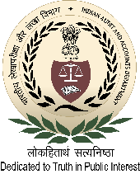
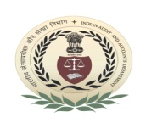
International Centre for Information Systems and Audit (iCISA)

A-52, Sector - 62, Institutional Area, Noida - 201307

Course Schedule
Workshop on “Information Systems Audit”
27 – 29 May 2019

Registration: 09:00 AM - 09:15 AM (Room no.111) and Inauguration: 09:15 AM - 09:30 AM (Room no. 213) on 27 May 2019
Date and Day | Session - I  (10:00AM to 11.15 AM) | Session - II  (11:45 AM to 01.00PM) | Session - III  (02:00PM to 03.15PM) | Session - IV  (03.45 PM to 05:00PM)
27 May 2019  (Monday) | IT Governance Framework  (ISO 38500) | Information Security  (ISO 27001) Audits | Network and Application Security
Faculty/Speaker | Mr. P. K. Konda, Director | Mr. Dhruv Bhola,  Dy. Director | Mr. Raghvendra Singh,  Dy. Accountant General
 | Room no. 213
28 May 2019  (Tuesday) | Data Quality,  Privacy & Security | Cloud Security Audits | GIGW and Web Security Audits
Faculty/Speaker | Mr. Deepak Mathews, Director | Mr. Nanda Dulal Das,  Dy. Accountant General | Mr. Mrinal Chawla, Dy. Director
 | Room no. 213
29 May 2019  (Wednesday) | Audit of Information Systems :  1.Acquisition, Development and Implementation  2. IS Controls |  | Audit of Information Systems :  3.IT Operation and Maintenance/BCP & DRP  4.IT Governance and Management
Faculty/Speaker | Experience sharing by the participants  Mr. K. R. Sriram, Director General, iCISA &  Mr. Abhay Singh, Dy. Director(Research & Innovation)
 | Room no. 213
Pre-evaluation Test: 09:30 AM - 10:00 AM on 27 May 2019
End Course Evaluation Test: 05:00 PM - 05:30 PM on 29 May 2019

Tea/Coffee Break: 11:15 AM - 11:45 AM Lunch: 01:00 PM - 02:00 PM Tea/Coffee Break: 03:15 PM - 03:45 PM

