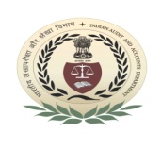
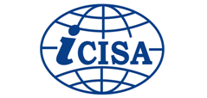
International Centre for Information Systems and Audit (iCISA)

A-52, Sector - 62, Institutional Area, Noida - 201307
लोकहितार्थ सत्यनिष्ठा
Dedicated to Truth in Public Interest
Course Schedule
“UMOJA training”
(for officers of IA&AD)
30 – 31 January, 2020

Date and Day | Session - I  (09:30AM to 10.45 AM) | Session - II  (11:15 AM to 12.30PM) | Session - III  (01:30PM to 02.45PM) | Session - IV  (03.15 PM to 04:30PM)
30 January 2020  (Thursday) | Introduction to ERP System, UMOJA(ERP System)
Faculty/Speaker | Mr. Deepak Viswanathan, SAO, RTI Chennai & Mr. Rohit Anand, SAO, RTI, New Delhi
Room no. 111
31 January 2020  (Friday) | Introduction to ERP System, UMOJA(ERP System)
Faculty/Speaker | Mr. Deepak Viswanathan, SAO, RTI Chennai & Mr. Rohit Anand, SAO, RTI, New Delhi
Room no. 111
Tea/Coffee Break: 10:45 AM - 11:15 AM Lunch: 12:30 PM - 01:30 PM Tea/Coffee Break: 02:45PM - 03:15PM

