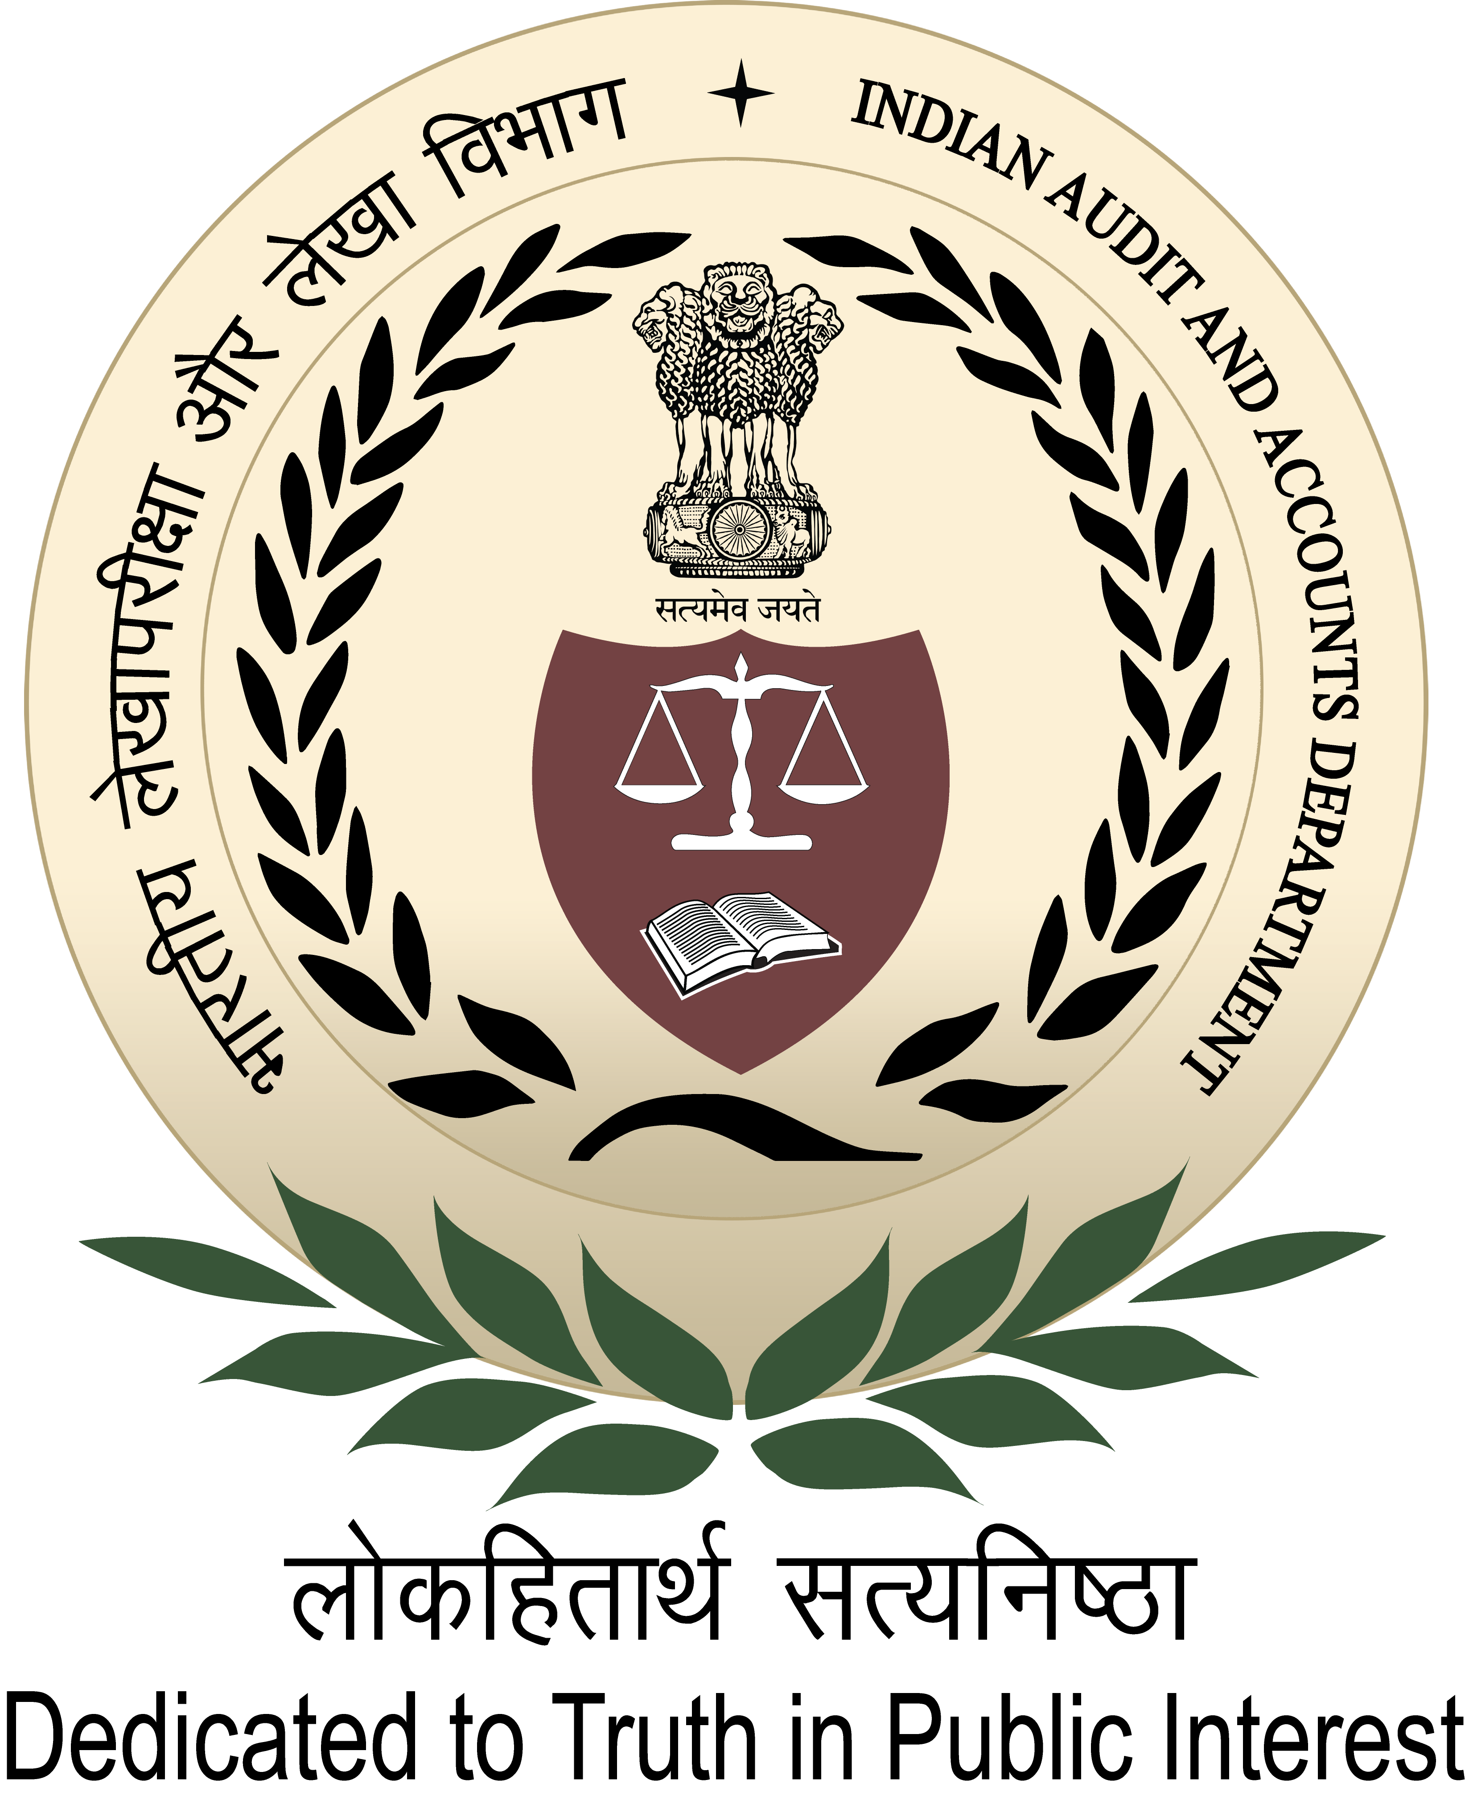
International Centre for Information Systems & Audit
A-52, Sector- 62, Institutional Area, Phase-II, Noida – 201307 (Uttar Pradesh)

146thInternational Training Programme

on
“Audit of e-Governance”
(07thJanuary to1stFebruary, 2019)

Course Schedule

146thITPFirstweek: e-Governance Framework and e-GovProject Implementation

Date & Day | Session 1  10:00– 11:15 Hours |  | Session 2  11:45 –13:00Hours | Session 3  14:00 – 15:15 Hours | Session 4  15:45 –17:00Hours
07 Jan. 2019  Monday | Briefing & Ice-breaking session |  | Introducing India | Inauguration at SAI India HQrs (C&AG of India)
Presentation by
SAI India participant
 | Room no. 108 |  |  | Seminar Hall
08 Jan. 2019  Tuesday | Digital transformation through e-Governance Projects |  |  | Implementation of e-Governance Projects:  An Implementer’s Perspective
 | Mr. AshisSanyal, Sr. Director (Retd.), MEITY,  Consultant for World Bank e-Governance Project and  Anchorfaculty for NISG and CDAC |  |  | Mr. TanmoyChakrabarty,  Group Government Affairs Officer, Tata Sons
 | Room no. 213
09 Jan. 2019  Wednesday | India Enterprise Architecture Framework (IndEA) |  |  | India Enterprise Architecture Framework (IndEA) |  | e-Gov Standards:  e-Governance Service Maturity Model
 | Mr. J. Satyanarayana, IAS (Retd.)  Chairman (Part time), UIDAI |  | Mr. Umesh Kumar Nandwani, Director General, STQC | Mr. Umesh Kumar Nandwani, Director General, STQC |  | Mr. Umesh Kumar Nandwani, Director General, STQC
 | Room no. 213
10 Jan. 2019  Thursday | e-Governance Project Life cycle :  Passport Seva Project |  |  | Automation of Direct Taxes:  Transforming Taxpayers’ services |  |  | Service level agreements and  Responsibility of vendors  in Data Centers
 | Mr. Golok K. Simli, Principal Consultant & CTO  PassportSeva, Ministry of ExternalAffairs, GoI |  |  | Visit to Centralized Processing Cell (TDS), Vaishali, Ghaziabad
 | Room no. 213 |  |  | At Aayakar Bhawan (Office of the Income-tax department)
11 Jan. 2019  Friday | Change Management in  e-GovProjects | e-Governance :  Implementation of G&ST through  Goods and Services Tax Network |  | Risk assessment in e-Governance Projects
 | Ms. Kajal Singh,IRS  Executive Vice President(Services),GSTN |  |  | Dr. Charru Malhotra  Associate Professor, IIPA
 | Room no. 213
12 Jan. 2019  Saturday | Social programme/Activity
13 Jan. 2019  Sunday | Social programme/Activity

146th ITPSecond week: Data Analytics using KNIME and Audit of e-Governance Projects using CAATs

Date & Day | Session 1  10:00 – 11:15 Hours |  | Session 2  11:45 – 13:00 Hours | Session 3  14:00 – 15:15 Hours | Session 4  15:45 – 17:00 Hours
14 Jan. 2019  Monday | COBIT: Enabling framework for IT systems |  |  | Country papers on “Audit of e-Governance” of respective SAIs
 | Mr. AshishMahajan,Associate General Manager  HCL Technologies |  |  | Presentation by the participants
 | Room no. 213
15 Jan. 2019  Tuesday | Data Analytics in Public Audit:  Principles and approach | Data analytics tool “Knime”: Overview and hands-on sessions |  | Data Analytics tool “Knime”:  Hands-on sessions
Mr. Abhay Singh,
Dy. Director (Research& Innovation and IT Audit)
 | Room no. 111
16 Jan. 2019  Wednesday | Introduction to IDEA:  Importing Data files, Obtaining an overview of the data | Hands on sessions :  Functions in IDEA and Extracting data relevant to audit |  | Hands on sessions :  Gathering evidence for errors in application controls & Audit Sampling using IDEA
Mr. K.P. Singh, Sr. AO and Mr. Anurag Krishna, AAO
(Research & Innovation and IT Audit),iCISA
17 Jan. 2019  Thursday | Hands on sessions : Functions in IDEA &  Audit of e-Governance Projects using IDEA |  |  | Hands on sessions : Functions in IDEA &  Audit of e-Governance Projects using IDEA
Mr. K.P. Singh, Sr. AO and Mr. Anurag Krishna, AAO
(Research & Innovation and IT Audit),iCISA
18 Jan. 2019  Friday | Data Privacy : Concepts, Issues and implications, Right to be forgotten | Assessment of Data privacy in e-Gov projects |  | Cyber laws and legal issues in  Implementation of e-Governance projects
 | Mr. Rahul Sharma, Cyber security advisor |  |  | Mr. PavanDuggal,  Cyber law expert and Sr. Advocate, Supreme Court of India
19 Jan. 2019  Saturday | Agra Visit/ Study Tour
20 Jan. 2019  Sunday | Study Tour to Jaipur/Udaipur

146th ITP Third week: Study tourcase studies &Theme Country day
Date & Day | Session 1  10:00 – 11:15 Hours | Session 2  11:45 – 13:00 Hours | Session 3  14:00 – 15:15 Hours | Session 4  15:45 – 17:00 Hours
21 Jan. 2019  Monday | Study Tour to Jaipur/Udaipur
22 Jan. 2019

Tuesday
23 Jan. 2019

Wednesday

24 Jan. 2019

Thursday
25. Jan 2019  Friday | Country paper presentation |  | Introduction to Digital Forensics: Digital Evidence Control;  Recovering files & Analysis and Reporting
 |  |  | Mr. A. S. A. Krishnan, Senior Consultant, STQC, Meity
26 Jan. 2019  Saturday | Social programme/Activity
27 Jan. 2019  Sunday | Social programme/Activity

146th ITP Fourth week: Emerging areas in IT & e-Governance andIssuesfor Audit

Date & Day | Session 1  10:00 – 11:15 Hours | Session 2  11:45 – 13:00 Hours | Session 3  14:00 – 15:15 Hours | Session 4  15:45 – 17:00 Hours
28 Jan. 2019  Monday | Introduction to Cloud Computing:  Concept & Security Concerns |  | Introduction to  OWASP Top 10 vulnerabilities | Web Application security:  Hands-on sessions
 | Mr.Iqbal Singh  Director – Cloud Deployment , Nokia |  | Mr. Apurv Kansal  Cyber security expert
 |  |  | Room no. 211
29 Jan. 2019  Tuesday | Internet of Things: Meaning and concepts;  Understanding IT and OT convergence;  Various layers of IoT Infrastructure Standards and Best Practices |  | Introduction to concepts of Block chain technology,  use of Block chain in government,  Auditing in Block chain environment- possible challenges
 | Colonel Inderjeet Singh  Chief Cyber Security Officer, Vara TechnologyPvt. Ltd. |  | Mr. Irfan Khan  Head, Hypermine Technologies
 | Room no. 213
30 Jan. 2019  Wednesday | Integrity issues in e-Procurement systems:  Underlying Risk areas and related Best practices |  | Audit of e-Procurement : Hands-on sessions
Mr. Jitendra Kohli, Managing Director
ElectronicTender.com (India) Pvt. Ltd.
 | Room no. 213 |  | Room no. 111
31 Jan. 2019  Thursday | Theme country day |  | Mobile Computing and Issues for audit
 | Auditorium |  | Mr. Apurv Kansal  Cyber Security Expert
 |  |  | Room no. 213
01 Feb. 2019  Friday | Country papers on “Audit of e-Governance” of respective SAIs |  | Valediction
 | Presentation by the participants
 | Room no. 213 |  | Auditorium

Other topics for consideration:  Topics |  |  | Resource person
1. | COBIT: Enabling framework for IT systems |  | Mr. Anindya Dasgupta/Mr. Madhav Chablani/Ms. Narmadha R
2. | PA Case Study on PAHAL-Direct Benefits Transfer for LPG(DBTL) |  | Mr. Ravi KiranUbale, Dy. Director  Ms. Nidhi Jain, Dy. Director and Mr. Sony Joseph, Asst. Audit Officer
3. | Re-engineering the government process  Case study: Implementation of Ground Penetrating Radar at FCI |  | Mr. Abhishek Singh, Executive Director, Food Corporation of India
4. | PA Case study-e-Governance project |  | Mr. Abdul Barri, Sr. Audit Officer, Mr. Praveen Kumar, AAO,ICISA
5. | Case study on audit of 3iMS | Impact of audit: e-registration:  G2C audit case study | Mr. D. Jaishankar, AG
6. | GSTN and Audit preparedness |  | Pr. Director (GST)
7. | Role of open source software in e-Gov | Meghdoot- The open cloud initiative | Faculty from CDAC
8. | Cloud Infrastructure, Services &Security Issues |  | Faculty from PwC/CDAC/ Mr. Madhav Chablani
9. | PA Case studies on Audit of Mission Mode Projects (Integrated, Union or State) |  | Respective field offices
10. | Reservation system to e-wallet: IRCTC Challenges & solutions in IT security-  Confidentiality, Integrity and Availability |  | Mr. NishantJaiswal, Joint General Manager  Indian Railway Catering and Tourism Corporation (IRCTC)
11. | Cyber laws and legal issues in implementation of e-governance projects |  | Mr. PavanDuggal,  Cyber law expert and Sr. Advocate, Supreme court of India
12. | e-Governance & Mobile Governance |  | Dr.Rajendra Kumar, JS Ministry of IT and Communication
13. | Role of Digital Signature, Smart cards, RFID and online identity verification for e-Governance |  | Prof.RajatMoona, Director General  Centre for Development of Advanced Computing (CDAC)

In the current century, Technology and Innovation have to be leveraged to serve the vast population of the country and its dream. Information and Communication Technologies today play a crucial role in economic and societal transformation. Digital India aims to harness this potential. Government is implementing the Digital India project as an umbrella programme to prepare India for knowledge based transformation into a digitally empowered Society and knowledge economy.
Digital India aims to provide the much needed thrust to the nine pillars of growth areas, namely Broadband Highways, Universal Access to Mobile Connectivity, Public Internet Access Programme,e-Governance: Reforming Government through Technology, e-Kranti - Electronic Delivery of Services, Information for All, Electronics Manufacturing,IT for Jobs and Early Harvest Programmes.
Further, with a vision to transform e-Governance for transforming Governance and keeping in view the need to utilize emerging technologies such as Cloud and mobile platform and focus on integration of services, the Government has also proposed to implement “e-Kranti : National e-Governance Plan (NeGP) 2.0” under the Digital India programme.
With NeGP as the prime focus, large investments are being made under NeGP and other e-governance projects. But one of the major reasons why the impact of this large investment is not so visible is due to lack of a standardized approach. To implement e-Governance projects successfully the solution has to beinteroperable, secure, scalable, reusable, leading to efficiency, effectiveness, reduction in cost and risk. To harness this, National Centre for e-Governance Standards and Technology has been set up by STQC Standardization, Testing and Quality Certification as a Centre of Excellence.

Shri J Satyanarayana
Chairman(part-time), UIDAI
Shri J Satyanarayana, IAS (Retd.) (1977, AP cadre) is the part-time Chairman of the Unique Identification Authority of India (UIDAI).
Shri Satyanarayana has close to four decades of experience in varied areas of governance and served as the Secretary, Department of Electronics and Information Technology from 2012 to 2014 before superannuation. He has been instrumental in training the political leaders & policy makers on the concepts and principles of e-Governance.

